Mezzofanti v1.0
Paul Meara and Imma Miralpeix

1: Mezzofanti is a simulator program that lets you explore how different initial conditions might affect the way individual speakers learn vocabulary over long periods of time. The program is based on work by Klaus Riegel (Riegel, 1968) which suggested that vocabulary acquisition might be modelled using some very simple equations.

2: The parameters that appear in the basic equation are:
A: the number of words available in the vocabulary the learner is exposed to;
m: an uptake factor;
t: the length of time available for learning

More advanced models that deal with bilingual inputs also use two additional parameters:
p: the proportion of time available for each of the two languages; and
o: the delay in starting the L2.

Mezzofanti lets you experiment with these parameters and explore how they affect the way vocabulary development takes place.

3: The Mezzofanti opening screen looks like this:

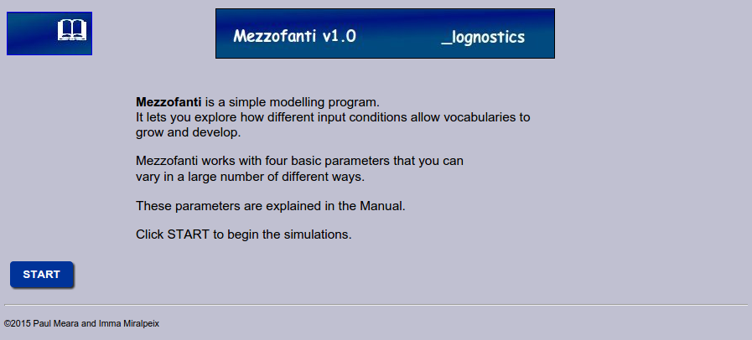

Click START to begin the program.

4: The Mezzofanti work space is shown on the next page.

You can work with a single language, or with two languages simultaneously. Each language is associated with four parameters.

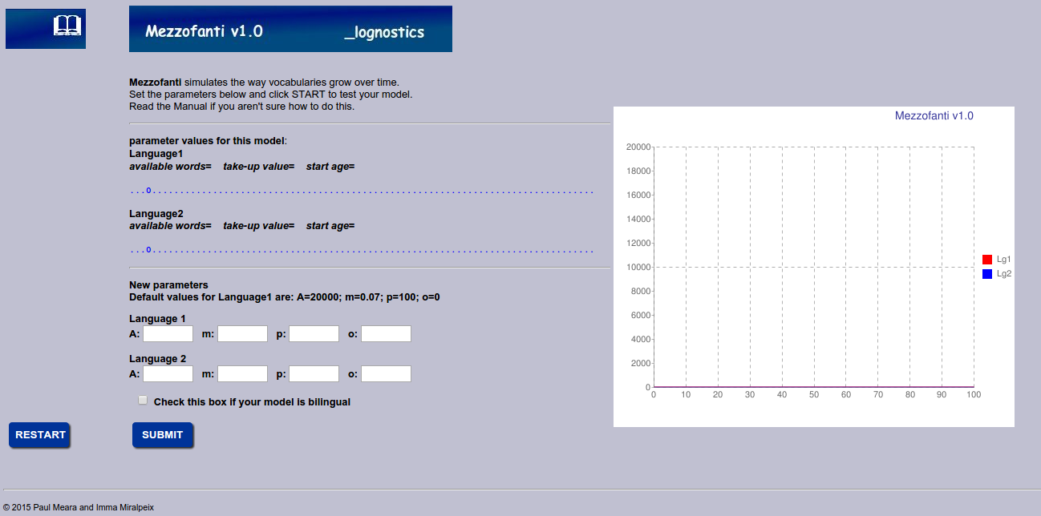

The default values for these parameters are:
A=20000 : m=0.07: p=100: o=0:

Parameter A is the number of words available in the environment being modelled. Conventionally, this figure is set to 20,000. This means that there are about 20,000 words available in the environment for the model to acquire. This figure is a simplification which needs to be explored. If you are working with multilingual models, then you might want to change this parameter to a lower figure: e.g. if you are modelling the way an adult learner acquires an L2 in evening classes, you might want to set the A parameter around two or three thousand words.

Parameter m is an uptake factor which determines how good the model is at picking up words in the environment. Conventionally, this factor is set to 0.07. This value means that under normal conditions the model acquires a vocabulary of around 10,000 words by age 10: this figure seems to correspond roughly to what happens in real life.
You can vary the m parameter if you want to explore what happens if your model is a precocious learner (set m to about 0.09 or higher), or a slow learner (reduce m to a value around 0.05). This feature is especially useful if you are modelling an L2 learner with poor vocabulary learning skills.

Parameter p indicates the amount of time that the model spends working with a language. If your model is a monolingual model, set this value to 1 (=100% of the time). If you are modelling bilingual cases, then you will need to vary this value appropriately. For instance, if you are modelling a bilingual child learning two languages simultaneously, then you might set parameter p for language 1 to 0.5 (=50% of the time) and parameter p for language 2 to 0.5 (= the other 50% of the time). If you are modelling an adult learner aquiring Chinese in an evening class for a few hours a week, then you might set parameter p to a much lower value.

Parameter o indicates the age at which the model starts to acquire the language. For Language 1 this figure will normally be 0. Other values might be appropriate for L2 learners – e.g. if you are modelling an adult L2 learner who starts learning Chinese at age 30, then set paramater o for Language 2 to 30.
For simplicity, parameter o should normally be divisible by 5.

5: When you have finished setting your parameters, click the SUMBIT button. Mezzofanti generates a graph which shows you how many words your model would be expected to acquire given its initial parameter settings.

6: The new display looks like this:

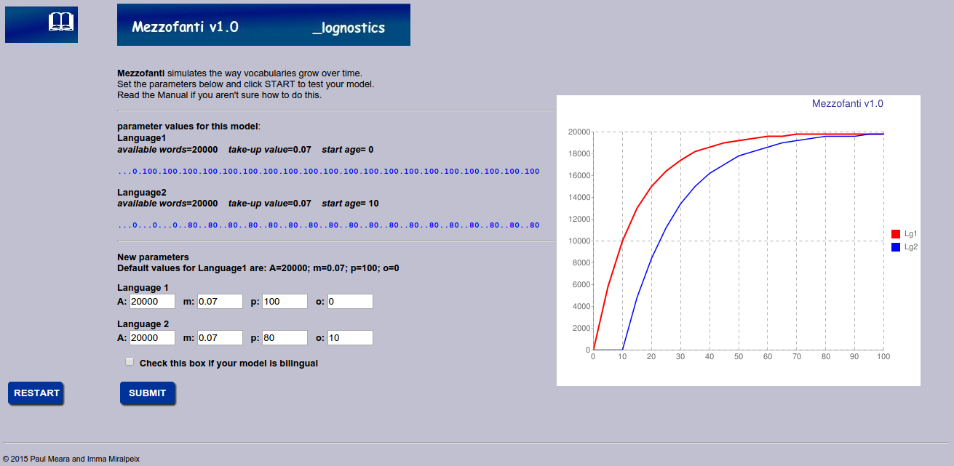

In this display, the red line shows vocabulary uptake in Language 1, and the blue line shows uptake in Language 2.
The blue number list reports the amount of exposure time each language has available to it. So, this graph compares how many words we might expect a monolingual Subject to learn, and how many words we might expect a bilingual learner to acquire. The bilingual's first exposure to the new language is at age 10, and the child is exposed to this language about 80% of the time.

7: If you want to compare two languages in a single individual, then tick the check box below the parameter settings. This will automatically adjust the amlount of time available for the learner's first language. For example, if you set the learner's second language to 40% exposure, then the learner's first language exposure will be automatically reduced to 60%.

8: A significant number of simplifications are built into Mezzofanti, and you need to be aware of their implications. The main assumptions are:
a) thatthe amount of vocabulary available is a constant and does not vary with time. (In real life, young chilldren are exposed to a limited vocabulary, and adolescents in formal schooling are exposed to a lot more vocabulary.)
b) that children start learning vocabulary from age 0. (Early vocabulary acqusition is probably much slower than later acquisition,)
c) that the uptake parameter m is constant throughout life.
d) that words once learned are not subject to attrition.
For the purposes of an exploratory model, these assumptions are not critical, but you need to think how changes in these assumptions might affect the way the model works, how you can simulate them by experimenting with the parameter combinations,and what new parameters might need to be included in a more advanced model.

9: For further discussion of Mezzofanti, see PM Meara and I Miralpeix (2015) Tools for Researching Vocabulary. Bristol: Multilingual Matters.

