LLAMA_B: The Manual

1: LLAMA_B is a test of your ability to learn the names of unfamiliar objects. It is was originally deisgned as one of a set of aptitude tests (Meara 2005), which were were downloadable and worked on Windows computers. This version runs on the web, and should be platform free. LLAMA_B is intended to assess the same sorts of skills as the vocabulary learning tasks in MLAT (Carroll and Sapon 1959) and PLAB (Pimsleur 1966)

The program presents you with a set of twenty unfamiliar objects, and asks you to learn their names. You have two minutes to complete this task. The program then tests you by presenting the objects one at a time, and asking you to identify the correct name from a list of all twentry names.

2: The opening screen looks like this:

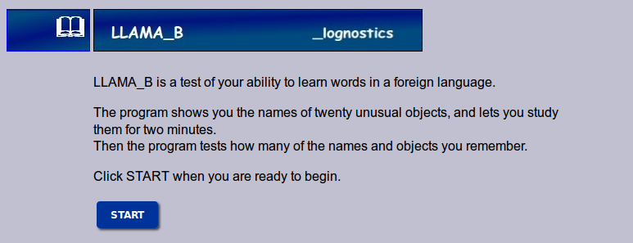

Click the START button to begin.

3: The program then presents you with a screen that contains twenty unusual objects. If you move the mouse over an object, then the program displays the object's name. Moving the mouse to another object will display a new name for the new object.

You have two minutes to study this material in any way that you like.

The pictures will disappear after two minutes. When this happens, Click the CONTINUE button to go to the testing phase,

The LLAMA_B learning screen

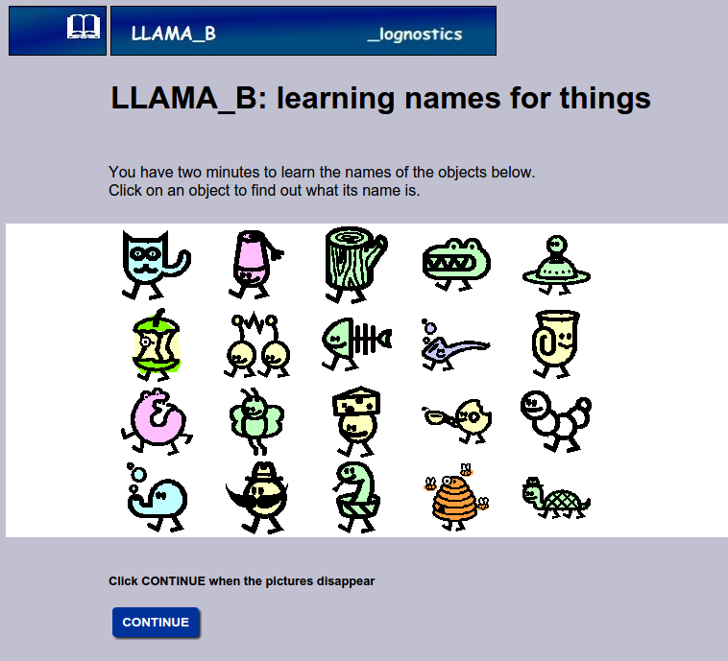

4: The LLAMA_B testing screen is shown on the next page.

The screen shows the same twenty pictures that you just learned, though the objects are positioned differently. The program asks you to find one of the objects and click on it. If you can't find the object the program is asking for, then just guess. When you click on your answer, the program will ask you to fond another object. There are twenty objects in all.
This part of the program is not timed, so you can take as long as you like over it.

5: After you have answered the last question, the program will display a report that tells you how many questions you answered correctly. The maximum score is 20.

The LLAMA_B test page

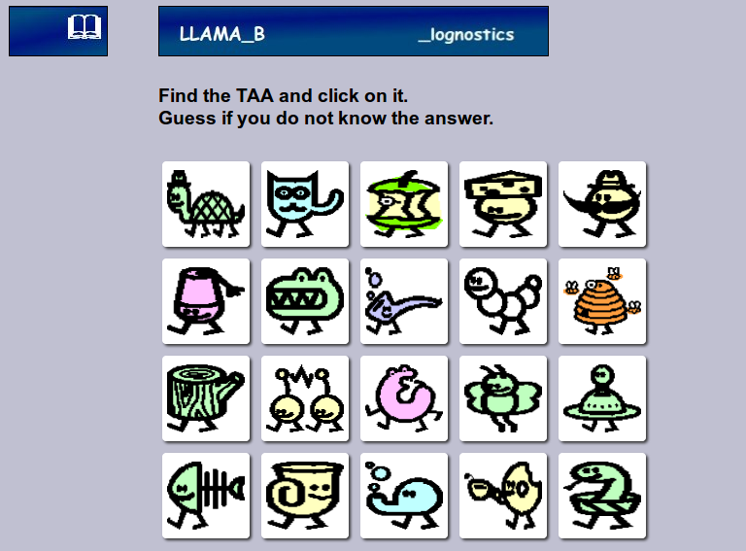

6: When you have finished the test, the program will report your score. The report screen looks like this:

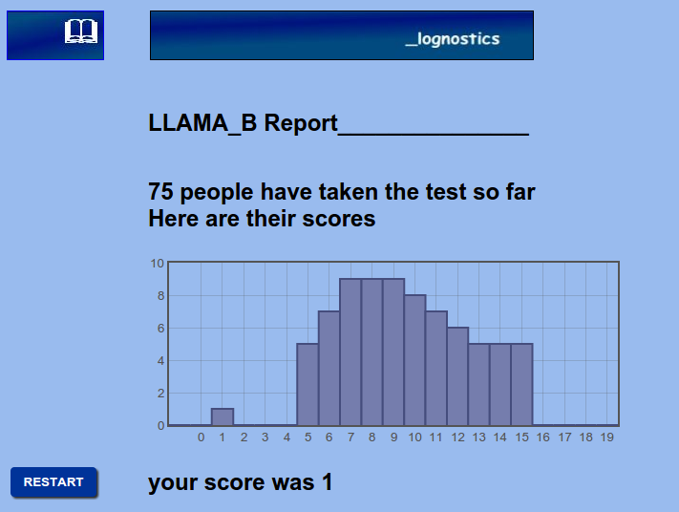
The report page tells you how many people have taken the test so far, and shows their results in the form of a graph. Your own score is also reported. The maximum score on the test is 20. The graph lets you see how you compare with other people who have taken the test

Click on the RESET button to reset the test. This takes you back to the opening screen.

7: For further discussion of LLAMA_B see: PM Meara and I Miralpeix Tools for Vocabulary Research. Bristol. Multilingual Matters. 2015.

8: References

Carroll, JB and S Sapon
Modern Language Aptitude Test. San Antonio, Texas: The Psychological Corporation. 1959.
Meara, PM
The LLAMA Language Aptitude Tests. Swansea: Lognostics. 2005.
Pimsleur, P
Pimsleur Language Aptitude Battery. New York: Harcourt, Brace & World. 1966.

