LLAMA_E v3.0 Sounds and Symbols
The Manual

Short Instructions

LLAMA_E v3.0 Sounds and Symbols

LLAMA_E is a test of your ability to make a connection between sounds that you are familiar with and a new writing system that will not be familiar to you. The reason for this test is that lots of learners find it difficult to realise that familiar letters do not always stand in for the sounds that you use in your first language. For instance, a C in Spanish can often represent the sounds that would normally be spelled TH in English, and OO in Dutch usually represents the sound that would be spelled OA in English. Part of developing a good accent in your foreign language is learning to recognise differences of this sort.

The opening page of the LLAMA_E program looks like this:

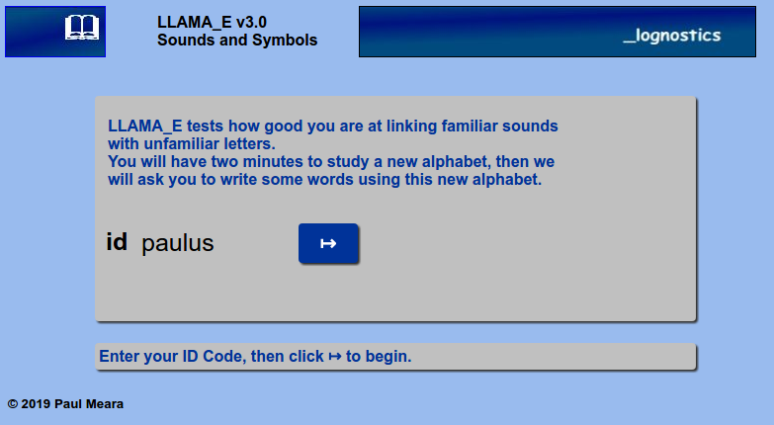
Figure 1: The LLAMA_E initial page

First enter your personal ID code. This should be a string of six characters that uniquely identifies you, and is not likely to be used by anybody else. This will normally be a six letter code like JOSMA or CF56EJ .

Next click the Ý button. This will take to to the display page, which is shown in Figure 2 below.

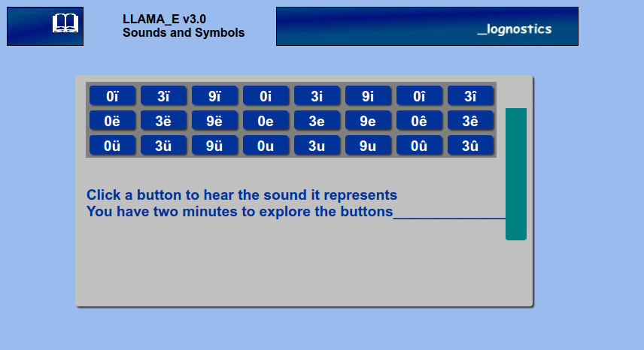
Figure 2: The LLAMA_E learning page

This screen contains a set of 24 buttons. Each button carries two letters in an unfamiliar alphabet.
If you click on one of these buttons, then the program will play the sound that is displayed on the button. The program allows you just two minutes to explore this soundscape. You can click as many buttons as you like, in any order that you like, and you can take any notes that you need to help you work out how this alphabet represents sounds. The green bar to the right of the screen tells you how much time you have left. After two minutes exploration time, the program will automatically move on to test how much you have learned.

The LLAMA_3 testing page is shown in Figure 3. It is worth while spending some time studying this window before you start the testing session.

This page contains a new set of buttons – twenty in all. Each of these buttons names a two syllable word, so the buttons are more complicated than the buttons you have worked with so far. When you are ready to start the testing, click the Ý button. This will make the program play a two syllable word. Decide which of the twenty buttons spells out your word and click it. If you aren't sure, then you can guess, or you can click the button marked ????

There are twenty test items in all. Your progress through the test is shown by the bars at the bottom of the page. When the program has tested all twenty items, it will instruct you to click the FINISH button. The program will then calculate your score and show you how your score compares with the scores of other people who have taken the test.
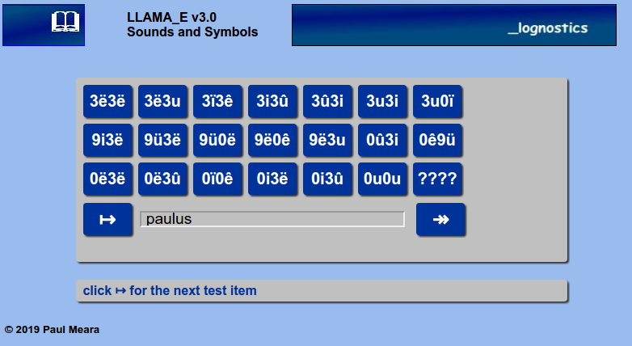
Figure 3: The LLAMA_E testing page

A typical report is shown in Figure 4. Here, the report shows that “qwerty” scored 18 points, or 90% correct. This is a very good score compared to other people who have taken the test so far.

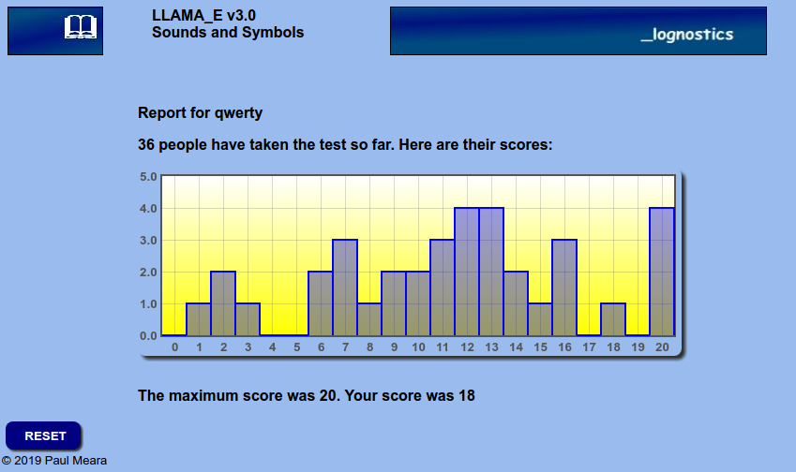
Figure 4: The LLAMA_E report page
TECHNICAL NOTES FOR RESEARCHERS
This document is a brief placeholder manual for the new release of LLAMA_E. LLAMA_E v3.0
was released on 11.04.2019 in a beta version. Comments are welcome.

This new version is part of our plan to replace ALL the free-standing LLAMA tests with test versions that run over the web. This is partly in response to the constant updating of MicroSoft operating systems, which require us to constantly update the existing versions of the tests and secure new licensing certificates. The new versions avoid these issues, and they allow us to make rapid changes in response to errors and bugs. They also allow us to collect data from users and build normed versions of the programs.

This version of the LLAMA_E test was developed in response to reports that previous versions were too easy for some test-takers, with the result that the test produced a bimodal distribution in which some test-takers got nearly full marks, while other test-takers scored close to zero. This version addresses this problem. The result is a very much harder test which we think will be a better discriminator.

The earlier versions of LLAMA_E used a set of 20 binary choice tests, where test-takers had to choose which one of a pair of representations spelled out the test word. One problem with this scoring method is that random guessing should produce a score of about 10 correct answers (50%). This results in a rather narrow range of scores, typically between 50 and 100%. In this new version, random guessing will usually generate only one of two correct answers. It is very difficult to guess the correct answer in the new format, as it requires test-takers to be able to scan a large number of plausible answers.

The test items are recorded using the same voice as the sounds that were recorded in the teaching phase of the program. Each test item consists of two syllables. There are some minor inconsistencies in the way the items were recorded, but these are not expected to affect the way the test works.

The previous section of this manual contains a brief set of instructions for test-takers. These instructions are currently available only in English. We will incorporate other languages if there is a need for this. Researchers should feel free to develop their own instruction set, or to prepare these instructions in other languages. It would be helpful, and greatly appreciated, if you could let us have copies of any such translations.

It is important to note that you should not override the instructions in the manual, or introduce new conditions that are not already in the instruction set. For example, it would be a mistake to tell test-takers not to write notes for this test.

In order to comply with the EU's General Data Protection rules, the program asks test-takers to provide a six-letter ID code which is stored along-side the test-taker's data. This is the only personal information that is stored by the program, and does not allow us to identify individual users. However, the scores are recoverable so that they can be used for research purposes. Data is scored in the form qwerty,18 (indicating that test-taker qwerty scored 18 correct answers). The program does not record which items qwerty got correct.

If you are a researcher running LLAMA_E with a number of test-takers, then you will find it helpful to issue them with ID codes that uniquely identify your test-takers. For example, if your project is being carried out in JohnPaul II University, then you might give the test-takers a code such as JP2001, JP2003, JP2004, and so on. This will probably allow us to archive all your data as a retrievable set.

Please note that the previous test-takers data shown in the report page will not be reliable until the beta version is replaced by a fully working version. If this is a problem for you, please contact us.
We will extend the report stage to include a standardised score once we have collected sufficient data for this to be sensible. It would help us to prepare this feature if you could let us know when you are using the LLAMA_E test, and approximately how many test-takers will be involved.

Comments on this beta version are very welcome. We will make every effort to correct bugs that users identify, and to incorporate improvements to the program. Please bear in mind that we don't work full-time on this project, and corrections may take some time. You will find an updated list of frequently asked questions and a record of bug fixes in the appendices to this manual.

Please send your comments and suggestions to:
p.m.meara@gmail.com

If you are using this program to collect data then please reference it as:
Meara, PM
LLAMA_E v3.00 Sounds and Symbols (beta)
Cardiff: Lognostics. 2019.

The small print
LLAMA_E v3.00 is made freely available to bona-fide researchers in exchange for comments and suggestions as to how to improve the format. The test should NOT be used in high stakes situations where reliability and accuracy are at a premium. No liability of any kind arising from the use or misuse of the test is accepted by the Author. By using the test you agreeing to this condition.

Frequently asked Questions

Can I use LLAMA_E with young children?
No. It's too hard for young children. LLAMA_E is designed to work with adult L2 learners. Personally, I wouldn't use it with anybody aged under 16.

Is LLAMA_E biassed favour of European language speakers?
I don't know. We don't have enough data from this new version. This question would make a good research project.

Why do i and u keep their usual values in Western European languages?
I wanted to mix up familiar and unfamiliar symbols.

Bugs and Fixes

No bugs so far.

