V_Words v2.0

1: V_Words produces a basic analysis of the vocabulary of short texts.

2: Load the text that you want to work with into the V_Words workspace. You can do this by typing your text directly, or by copying a pre-prepared text into the workspace.

3: Edit your text as necessary.

4: V_Words ignores punctuation marks. If there are any other symbols ibn your text that you want V_Words to ignore, you can add them the punctuation list underneath the workspace.

5: Click the SUBMIT button.

6: V_Words generates a report that looks like this:

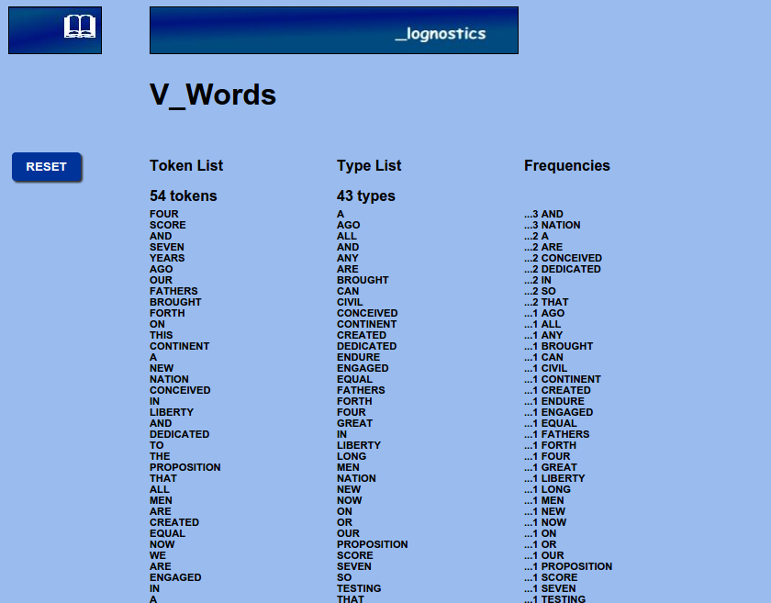

Column 1 on the left is a simple list of all the words in the text.
Column 2 is an alphabetically organised type count for the text.
Column 3 is a frequency ordered type count for your text.

7: You can save the reports by copying and pasting the relevant columns to a new document.

8: Click the RESET button to return to the data input page.

9: For further discussion of V_Words see:
PM Meara and I Miralpeix Tools for Vocabulary Research. Bristol. Multilingual Matters. 2016.

