V_Lists v1.0

1: V_Lists allows you to carry out some basic operations on word lists. Specifically, V_Lists takes two word lists as input and reports the words which occur in only one of the lists, the words which occur in both of the lists and a cumulative list that contains words that appear in either of the original lists.

2: The V_Lists work space contains two data slots. Copy your first word list into the first slot, and the second list into the second slot. The data should be formatted with one word to a line, as shown below.

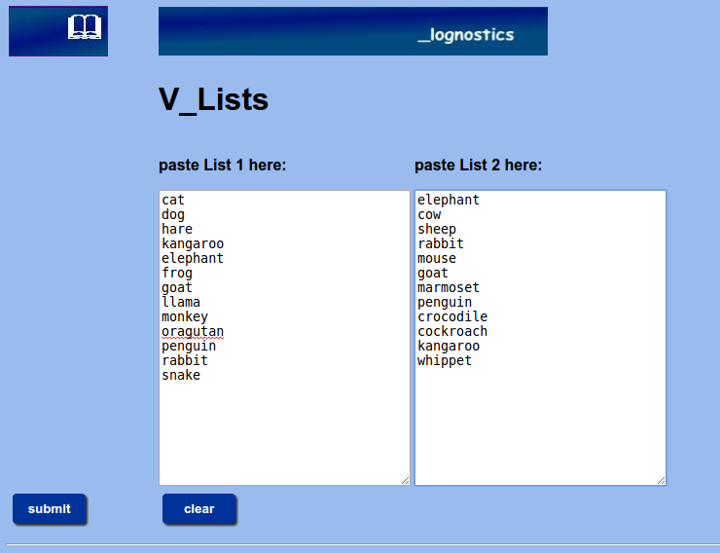
The V_Lists input page.

3: Click the SUBMIT button to analyse your data.

4: V_Words generates a report that looks like the figure on the next page.
The report consists of four columns of data.
Column 1 lists the word types that appear in list 1 but not in list 2.
Column 2 lists the word types that appear in list 2 but not in list 1.
Column 3 lists the words which occur in both list 1 and in list 2. Column 4 is a cumulative word list that contains the word types occurring either in list 1 or in list 2.
5: You can save the reports by copying and pasting the relevant columns into a new document.

6: Click the RESET button to return to the V_Lists input page.

7: For further discussion of V_Lists see:
PM Meara and I Miralpeix Tools for Researching Vocabulary. Bristol. Multilingual Matters. 2016.

